**Shau Kei Wan Methodist Kindergarten**

**Notice of "Cultural Heritage" Activity**

**Dear Parents,**

Our kindergarten has been actively promoting activities related to Chinese culture in recent years to cultivate children's understanding of traditional Chinese culture. This year, we will incorporate a Chinese cultural theme into the birthday party. To enhance children's interest in learning and strengthen home-school cooperation, we sincerely invite parents to come to school on the day of the birthday party to lead or share activities related to the birthday party theme. This will help pass on knowledge of Chinese culture, and we encourage parents to participate actively.

Details of the "Cultural Heritage" activity are as follows:

• Date: November 1, 2024 (Monday)

• Time: 9:05 AM to 9:30 AM

• Location: Classrooms of our kindergarten

• Birthday Party Theme: Chinese Folk Games (Examples: Jianzi, Tuhuo, Jump Rope, Top Spinning, etc.)

**Activity Suggestions:** Share stories about folk games, demonstrate folk games, lead children in experiencing folk games, etc.

**Notes:**

1. To ensure the smooth progress of the activity, please prepare the content

and related props or materials in advance, and introduce the activity to the class teacher one week before the event so that the teacher can make appropriate arrangements.

2. If the number of participating parents exceeds capacity, we will select participants by lottery.

If parents have any inquiries, please contact the class teacher at our office number

3156 2523 during office hours.

Attached is a reply slip, and we kindly ask parents to return it to the class teacher by October 16. Thank you!

Thank you for your attention!

Shau Kei Wan Methodist Kindergarten

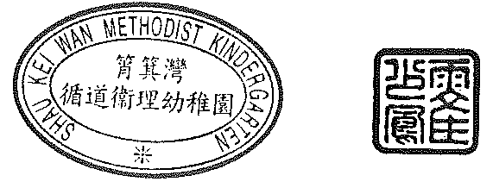

Principal

Ng Chiu Lan Jenny

Date: 10th October,2024.